La Cité Collégiale
Sennheiser’s Digital 6000 and MobileConnect in 360-degree theatre at new ‘Excentricité’ Building

Ottawa, ON, June 12, 2019 – As one of the leading applied arts and technology colleges in Canada, La Cité Collégiale, located in the nation’s capital, prides itself on its innovative, forward-thinking approach. This initiative is extremely apparent in its recently opened Excentricité education facility — a $30 million, 34,000-square-foot technology pavilion officially opened in September 2018 featuring a variety of spaces, including a bistro, gym and 4,000-square-foot immersive theatre-esque space boasting 360-degree sound and video.

La Cité Collégiale installed Sennheiser’s Digital 6000 system in its new Excentricité building which features a 360-degree room used for theatre productions, conferences and band performances  (Image courtesy of La Cité Collégiale) | 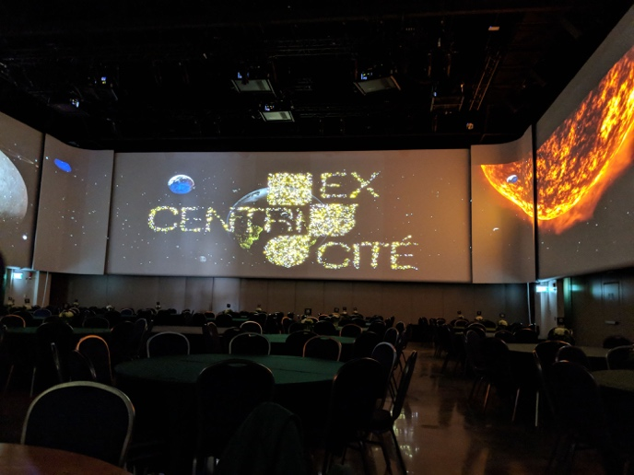

The 360-degree theatre in Excentricité, dubbed The Studio, seats 1,200 people and is used for conferences, live music performances and play productions. Patrick Roy of systems integrator group CBCI Telecom has collaborated with La Cité a variety of times in the past and spec’d the entire Excentricité project. He selected Sennheiser’s Digital 6000 wireless system for its ability to eliminate feedback, its wide dynamic range and its Dante connectivity — a key feature for The Studio. Staying true to its state-of-the-art roots, Dante is the future of audio networking and was a key component for La Cité when designing its audio system.

“The Studio features a complete digital system over network with a Dante board,” Roy explained. “It was La Cité’s vision to have a complete Dante system — both audio and video — in the 360-degree Studio. Dante is the new wave with consoles, mics and speakers all changing to this platform. Depending on the network, it can be much cheaper. So, the Dante connectivity coupled with its high sound quality made the Digital 6000 a perfect fit.”

Installed alongside The Studio’s Digital 6000 system was Sennheiser’s MobileConnect — the company’s system and app that streams audio content via Wi-Fi to smartphones. The MobileConnect smartphone hearing system app is ideal for use in universities where it provides students with personalized audio. Theatres also benefit from the system as it’s an ideal application for attendees using hearing aids. Since The Studio holds both conferences and plays performances, the MobileConnect system was a perfect fit for Roy and his team.

“MobileConnect is great because it offers a state-of-the-art audio experience and is easy to use for the end-user,” Roy said. “It really enhances the listening experience.”

Feedback eliminated
The Studio boasts a whopping 252 feet of 360-degree video, and with close to 50 speakers installed to support the immersive audio-visual experience, Roy and his team were tasked with finding an audio system that would keep feedback to a minimum.

“With so many speakers in one space, you really need a system that can prevent feedback,” Roy explained. “The Studio features a d&b Soundscape system, two line arrays and Renkus-Heinz ICONYX speakers placed behind the screens as well as speakers specifically for conferences. Finding an audio system that could eliminate feedback was important.”

La Cité’s new Excentricité building features close to 50 loudspeakers for the immersive audio experience. Digital 6000 was the microphone system of choice to keep feedback to a minimum  (Image courtesy of La Cité Collégiale) | 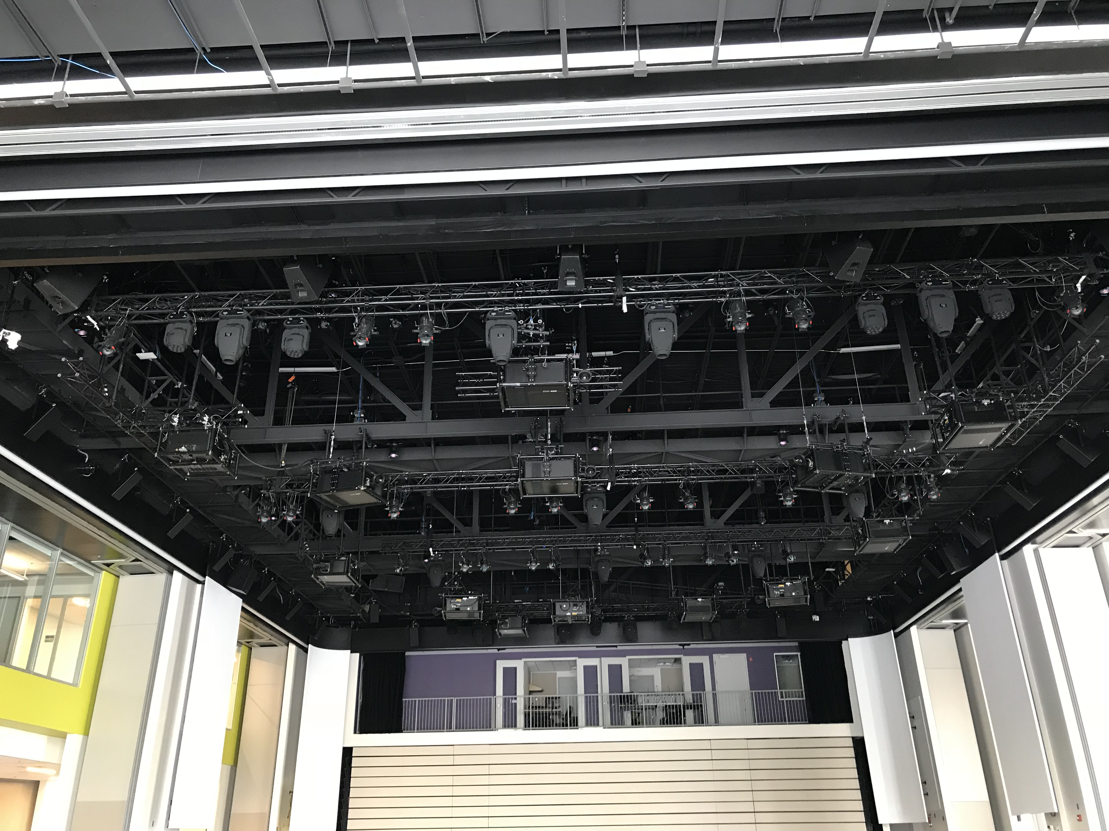

A truly universal system
Because The Studio holds a variety of different events — from conferences to theatre productions to live band performances — Roy needed a multi-purpose system that could deliver crystal-clear audio whatever the application.

“The Digital 6000 Series works great with guitars for live bands and because the space can be rented out for live performances, this was important,” Roy explained. “The Studio was a unique project because of the 360-degree aspect. We made sure to choose only the best system for this project to make the sound adaptable for whatever the space held, whether it was a conference or a play.”

Positive response
After using the system for a few months, Roy said La Cité’s staff have been blown away by the audio in the 360-degree Studio. “The sound in The Studio has far surpassed La Cité’s expectations,” Roy said. “Even the patrons that have attended a performance in the 360-degree studio are saying great things about the audio experience.”

About Sennheiser
Shaping the future of audio and creating unique sound experiences for customers – this aim unites Sennheiser employees and partners worldwide. Founded in 1945, Sennheiser is one of the world’s leading manufacturers of headphones, microphones and wireless transmission systems. With 21 sales subsidiaries and long-established trading partners, the company is active in more than 50 countries and operates its own production facilities in Germany, Ireland, Romania and the USA. Since 2013, Sennheiser has been managed by Daniel Sennheiser and Dr. Andreas Sennheiser, the third generation of the family to run the company. In 2017, the Sennheiser Group generated turnover totaling €667.7 million. www.sennheiser.com

Local press contacts

Sarah James Victoria Chernih
sarahj@gasolinemedia.com victoria.chernih@sennheiser.com
+44 1483 223333 +44 7881 091687

